CSCI 151/152 Examples of One-Dimensional Array Processing

//--V E R S I O N 1 -------------------------------------------------------------------------------------
//
// This program will input daily temperature values for one week, calculate the average of all the
// temperatures, determine the highest and lowest temperatures input, and output the
// temperatures with an indication of how far above or below average each is.
//---------------------------------------------------------------------------------------------------------

#include <iostream>
#include <iomanip>
using namespace std;

const int DAYS = 7;

int main ()
{
int temp[DAYS]; // Array of temperatures to be input
int day; // Loop counter to number the days
int hiTemp; // Value of highest temperature
int loTemp; // Value of lowest temperature
int sum;
double avgTemp;

sum = 0;
hiTemp = -999; // Initialize hiTemp so that any real temp would be greater.
loTemp = 999; // Initialize loTemp so that any real temp would be less.

cout << "Enter a temperature for each day as prompted:\n";

for (day = 0; day < DAYS; day++) // For each day:
{
cout << "Day " << day + 1 << " : "; // Prompt with day # (1 - 7) rather than subscript,
cin >> temp[day]; // Read temperature for that day,

sum += temp[day]; // Add it to a sum,

if (temp[day] > hiTemp) // Check to see if it is > than the highest seen so far
hiTemp = temp[day]; // If it is, save it as the highest seen so far

if (temp[day] < loTemp) // Check to see if it is < than the lowest temp seen so far
loTemp = temp[day]; // If it is, save it as the lowest seen so far
}

avgTemp = static_cast<double>(sum)/DAYS;
cout << fixed << showpoint << setprecision(1);
cout << "\nThe average temperature is " << avgTemp << endl;
cout << "The highest temperature is " << hiTemp << endl;
cout << "The lowest temperature is " << loTemp << endl << endl;

cout << "Day Temperature Above/Below Avg" << endl;
cout << "-------------------------------" << endl;
for (day = 0; day < DAYS; day++)
{
cout << setw(2) << day + 1 << setw(9) << temp[day] << setw(15)
<< showpos
<< temp[day] - avgTemp << noshowpos << endl;
}

system(“pause”);
return 0;
}
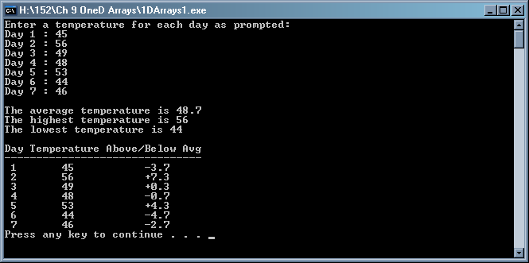

//--- V E R S I O N 2 -------------------------------------------------------------------------------------
//
// This version of the program will read a month’s worth of daily temperature values from a file.
// In addition to the processing done by the previous version, this program will identify the number
// of the day when the lowest and highest temperatures were recorded.

// This version of the program also demonstrates that often the collections of values which we store
// an array may vary in size from one run of the program to the next. The array must be declared
// with the largest size possible, and we must be sure we don’t attempt to process whatever values
// may be in the unassigned element positions at the end of the array (we would need to count how
// many values are actually input and stored).

// Since the number of days in a month can range from 28 to 31, we have to declare the array of
// temperatures large enough for the month with the most days. And we need to know how many
// days are in the month currently being processed. My sample data file will contain on its first line
// the number of the month to be processed, and we can use that month number to find out how
// many days are in that month. If the specific month is unknown, we would have to count the
// temperature values as they are input to know how many there are to be processed.
//-----------------------------------------------------------------------------------------------------------

#include <iostream>
#include <iomanip>
#include <fstream>
using namespace std;

int NumDaysInMonth (int month); // prototype for user-defined function

int main ()
{
int temp[31]; // Array of temperatures big enough for any month
int day; // Loop counter to number the days
int hiDay; // Subscript (day number) of the highest temperature
int loDay; // Subscript (day number) of the lowest temperature
double sum;
int monthNum;
int daysInMonth;
double avgTemp;

ifstream dailyTemps ("dailyTemps.txt");

if (dailyTemps.fail())
cout << "can't open the input file\n";
else cout << "input file is open\n";

sum = 0;
hiDay = 0; // Assume first day's temp is highest (assign value of first subscript)
loDay = 0; // Assume first day's temp is also lowest (assign value of first subscript)

dailyTemps >> monthNum; // I’m assuming the month number is a valid value 1-12
daysInMonth = NumDaysInMonth (monthNum);

for (day = 0; day < daysInMonth; day++) // For each day:
{
dailyTemps >> temp[day]; // Read temperature for that day

sum += temp[day]; // Add it to a sum

if (temp [day] > temp[hiDay]) // If this temp is greater than the highest temp seen so far,
hiDay = day; // save the day (subscript) of this new high temp

if (temp [day] < temp[loDay]) // If this temp is less than the lowest temp seen so far,
loDay = day; // save the day (subscript) of this new low temp
}

avgTemp = sum / daysInMonth;
cout << fixed << showpoint << setprecision(1);
cout << "\nThe average temperature is " << avgTemp << endl;

// When printing the day number for the high and low temps, add 1 to the hiDay and loDay variables
// to convert the 0-30 values into 1-31 values for convenience in reading the output.

cout << "The highest temperature " << temp[hiDay] << " occurred on day "
<< hiDay + 1 << endl;
cout << "The lowest temperature " << temp[loDay] << " occurred on day "
<< loDay + 1 << endl << endl;

cout << "Day Temperature Above/Below Avg" << endl;
cout << "-------------------------------" << endl;
for (day = 0; day < daysInMonth; day++)
{
cout << setw(2) << day + 1 << setw(9) << temp[day] << setw(15) << showpos
<< temp[day] - avgTemp << noshowpos << endl;
}

system("pause");
return 0;
}

int NumDaysInMonth (int month) // This function assumes valid month numbers
{ // of 1 – 12, inclusive.
switch(month)
{
case 9 : // September
case 4 : // April
case 6 : // June
case 11 : // November
return 30;
case 2 : // February (in a non-leap year)
return 28;
default : // for any other month
return 31;
};
}

// Another way of retrieving the number of days for the input month is to store those values in an
// array and use the month number as a subscript to access the correct value:

int monthDays [12] = { 31, 28, 31, 30, 31, 30, 31, 31, 30, 31, 30, 31 };
// Jan Feb Mar Apr May Jun Jul Aug Sep Oct Nov Dec

dailyTemps >> monthNum;

// The month number input will be a 1-12 value, but my array is indexed with subscripts of 0-11, so
// I need to compensate to get the correct array value.
// For example, if I read in month number 1, I need a subscript of 0, so I subtract 1 from month
// number. If I read in month number 2 and subtract 1, I get a subscript of 1, etc.

daysInMonth = monthDays[monthNum - 1];

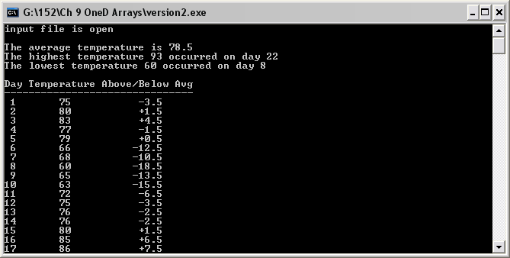
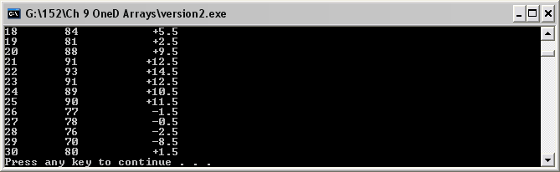

// VERSION 3 ----------------------------------------------------------------------------------------------
// This is version 2 using functions to simplify main and hide the details of how the program works.
//------------------------------------------------------------------------------------------------------------

#include <iostream>
#include <iomanip>
#include <fstream>
using namespace std;

const int DAYS = 31;

void InputTemps(int temp[], int & daysInMonth);
double ArrayAverage (const int temp[DAYS], int daysInMonth);
int LargestInArray (const int temp[], int daysInMonth);
int SmallestInArray (const int temp[], int daysInMonth);
void FindHighest_Lowest (const int temp[] , int & hiTempSub, int & loTempSub, int daysInMonth);
void Display (double avgTemp, int hiTemp, int loTemp, const int temp[], int daysInMonth);

int main ()
{
int temp[DAYS]; // Array of temperatures to be input
int hiTemp; // Value of highest temperature
int loTemp; // Value or lowest temperature
int hiTempSub; // Subscript of highest temperature
int loTempSub; // Subscript of lowest temperature
double avgTemp;
int daysInMonth ;

InputTemps (temp, daysInMonth);
avgTemp = ArrayAverage (temp, daysInMonth);
hiTemp = LargestInArray (temp, daysInMonth);
loTemp = SmallestInArray (temp, daysInMonth);
Display (avgTemp, hiTemp, loTemp, temp, daysInMonth);

// or use subscripts instead of the actual temperature values (this would allow me to identify when
// the highest and lowest temperatures were recorded:
// FindHighest_Lowest (temp, hiTempSub, loTempSub, daysInMonth );
// Display (avgTemp, temp[hiTempSub], temp[loTempSub] , temp, daysInMonth );

system("pause");
return 0;
}

//------------ I N P U T T H E T E M P E R A T U R E S ----------------------------------

// Call: InputTemps (temp, daysInMonth);

void InputTemps ( int temp[DAYS], int & daysInMonth )
{
ifstream dailyTemps ("dailyTemps.txt"); // File can be opened locally because
int day; // the function is only called once
int monthNum;

dailyTemps >> monthNum >> daysInMonth;

for (day = 0; day < daysInMonth; day++) // For each day:
{
dailyTemps >> temp[day]; // Read temperature for that day

}
}
//------------- C A L C U L A T E A V E R A G E T E M P E R A T U R E ------------------

// Call : avgTemp = ArrayAverage (temp, daysInMonth);

double ArrayAverage ( const int t[], int daysInMonth )
{ // const means function can't change any
int day; // of the array element values
int sum = 0;

for (day = 0; day < daysInMonth; day++)
sum += t[day] ;
return static_cast<double>(sum) / daysInMonth;
}

//--------------------- F I N D T H E H I G H E S T T E M P E R A T U R E ----------------------

// Call: hiTemp = LargestInArray (temp, daysInMonth);

int LargestInArray ( const int temp[], int daysInMonth )
{
int day;
int hiTemp = -999; // guarantee that the first real temperature is the largest seen so far

for (day = 0; day < daysInMonth; day++) // for each temperature:
if (temp[day] > hiTemp) // If this temp is greater than the largest so far,
hiTemp = temp[day] ; // remember this one as the largest so far
return hiTemp;
}

//---------------------- F I N D T H E L O W E S T T E M P E R A T U R E ----------------------

// Call: loTemp = SmallestInArray (temp, daysInMonth);

int SmallestInArray ( const int temp[], int daysInMonth )
{
int day;
int loTemp = 999; // guarantee that the first real temperature is the smallest seen so far

for (day = 0; day < daysInMonth; day++) // for each temperature:
if (temp[day] < loTemp) // If this temp is less than the smallest so far,
loTemp = temp[day]; // remember this one as the smallest so far
return loTemp;
}

// or //------- F I N D P O S I T I O N O F H I G H E S T A N D L O W E S T T E M P S -------

// Call: FindHighest_Lowest (temp, hiTempSub, loTempSub, daysInMonth );

void FindHighest_Lowest (const int temp[], int & hiTempSub, int & loTempSub, int daysInMonth)
{
int day;

hiTempSub = 0; // assume first temperature is the highest
loTempSub = 0; // assume first temperature is lowest

for (day = 1; day < daysInMonth; day++) // for each temp, starting with second element:
{
if (temp[day] > temp[hiTempSub]) // if this temp is greater than largest so far,
hiTempSub = day; // remember where largest so far is located
if (temp[day] < temp[loTempSub]) // if this temp is less than smallest so far,
loTempSub = day; // remember where smallest so far is located
}
}

//------------ D I S P L A Y R E S U L T S -------------------------------------------------

// Call: Display (avgTemp, hiTemp, loTemp, temp, daysInMonth);

// or: Display (avgTemp, temp[hiTempSub], temp[loTempSub] , temp, daysInMonth );

void Display (double avgTemp, int hiTemp, int loTemp, const int temp[], int daysInMonth )
{
int day;

cout << fixed << showpoint << setprecision(1);
cout << "\nThe average temperature is " << avgTemp << endl;
cout << "The highest temperature is " << hiTemp << endl;
cout << "The lowest temperature is " << loTemp << endl << endl;

cout << "Day Temperature Above/Below Avg" << endl;
cout << "-------------------------------" << endl;

for (day = 0; day < daysInMonth; day++)
{
cout << setw(2) << day + 1 << setw(9) << temp[day]
<< setw(15) << showpos << temp[day] - avgTemp << noshowpos << endl;
}
}

Output for this version of the program is the same as for version 2 if the FindHighest_Lowest function is called and the days of the high and low temperatures are displayed in addition to the temperature values themselves.

